MT5 Reference
Check the link

Moving Average MA

Simple Moving Average (SMA)
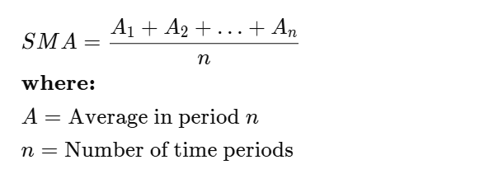

Exponential Moving Average (EMA)
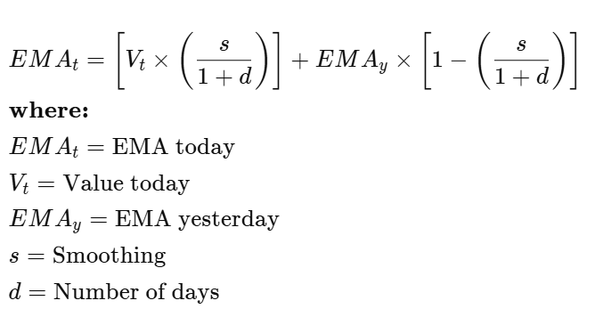

SMA vs. EMA
The calculation for EMA puts more emphasis on the recent data points. Because of this, EMA is considered a weighted average calculation.² In the figure below, the number of periods used in each average is 15, but the EMA responds more quickly to the changing prices than the SMA.
The EMA has a higher value when the price is rising than the SMA, and it falls faster than the SMA when the price is declining. This responsiveness to price changes is the main reason why some traders prefer to use the EMA over the SMA.

Moving average convergence/divergence (MACD)

MACD Calculation
$$\text{MACD}=\text{12-Period EMA }-\text{ 26-Period EMA}$$
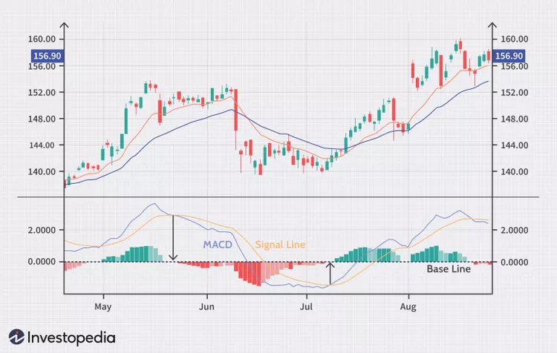

Reference
1.

Understanding Oscillators
Oscillators are typically used in conjunction with other technical analysis indicators to make trading decisions. Oscillators are most useful when there's no clear trend, like when a stock trades sideways. The most common oscillators are the:

Reference
1.
Stochastic Oscillator
Relative Strength (RSI)
Rate of Change (ROC)
Money Flow (MFI)

Bollinger Bands

Bollinger Bands Cheat Sheet
Bollinger Band Action | What This Indicates | Potential Reaction
Upward middle band | Indicates an uptrend | Buy or hold long positions
Downward middle band | Suggests a downtrend | Sell or hold short positions
Narrow bands (squeeze) | Less volatility; potential for significant price move | Prepare for a breakout; consider entry points
Price touching or moving outside the upper band | Potentially overbought (poised to fall in price) | Consider selling, shorting, or tightening stop-loss orders
Price touching or falling outside the lower band | Potentially oversold (poised to go up) | Buying or tightening stop-loss orders
Price bounces off the lower band | The upper band becomes a potential exit point if the trend reverses | Consider taking profits or setting up a trailing stop-loss
Price touches the upper band | The lower band becomes a potential target if the reversal occurs | Consider taking profits or setting a trailing stop-loss
Price rebounds from upper or lower bands toward the middle band | Potential buying or selling opportunity, especially in ranging markets ("Bollinger Bounce") | Enter long or short positions; set stop-loss orders
Price move starting at the upper band and continuing outside it, with increased volume | Signals a potential breakout | Enter long positions; set stop-loss orders below recent lows
Decisive move below the lower band, with high volume | Could mean a breakdown or the start of a new bearish trend | Enter short positions; set stop-loss orders above recent highs
Widening bands after a squeeze | Could indicate an imminent breakout | Prepare for entry, watch for confirmation signals
Widening bands | Signals increase in volatility and the potential beginning of a strong price trend | Adjust risk management; consider trend-following strategies
Tightening bands (squeeze) | Suggests a period of lower volatility and consolidation; often a precursor to a major price move or breakout | Prepare for a breakout; consider entry points; tighten stop-loss orders
Longer squeeze | Could indicate a more potent breakout coming | Prepare for a larger price move; increase position size
Tightening bands | Could mean there's no consensus in the market about the future price direction | Adjust risk management; wait for clearer signals before entering positions

Reference
EMA

ATR

Uses
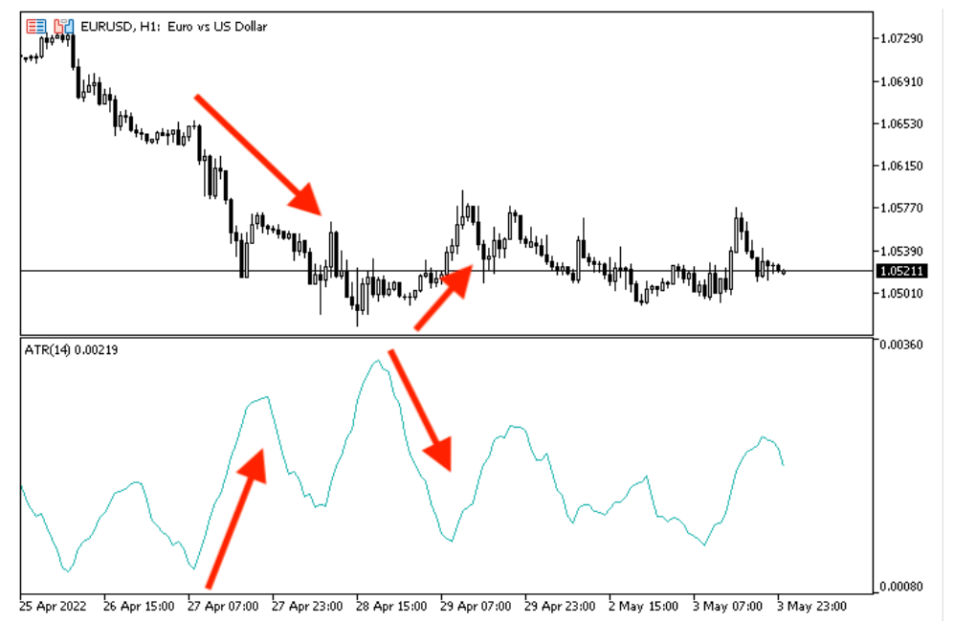

The ATR indicator is not accurate to generate trading signals as we already know based on its calculation. It considers only the magnitude of range but its beauty is that it is one of the best tools that can help to apply a suitable position size, stop loss, and take profit.

Buy and Sell ATR Indicator:
Combines ATR with trend detection and RSI to suggest potential buy/sell signals.

References
1. Learn how to design a trading system by ATR

Parabolic SAR

Parabolic SAR Introduction
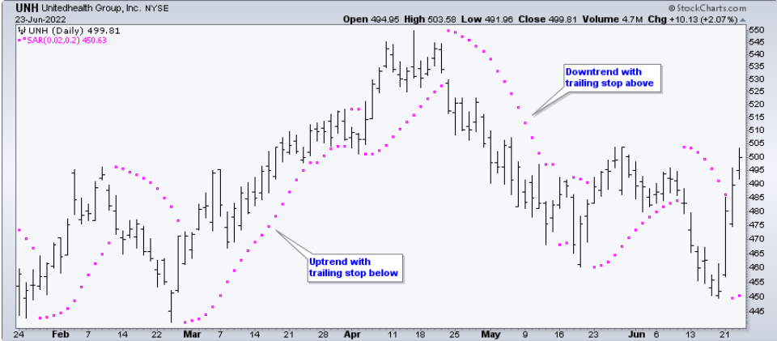

Parabolic SAR Calculation

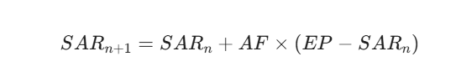
Formular

- Extreme Point (EP): The highest high reached in the current uptrend or the lowest low reached in the current downtrend
- Acceleration Factor (AF): Starting at .02, AF increases by .02 each time the extreme point makes a new high. AF can reach a maximum of .20, no matter how long the the trend extends.

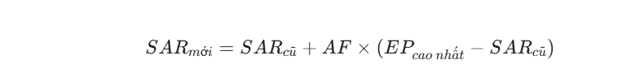
Rising SAR

Current SAR = Prior SAR + Prior AF(Prior EP - Prior SAR)
13-Apr-10 SAR = 48.28 = 48.13 + .14(49.20 - 48.13)

Falling SAR


Current SAR = Prior SAR - Prior AF(Prior SAR - Prior EP)
9-Feb-10 SAR = 43.56 = 43.84 - .16(43.84 - 42.07)

Acceleration Factor (AF): Effective
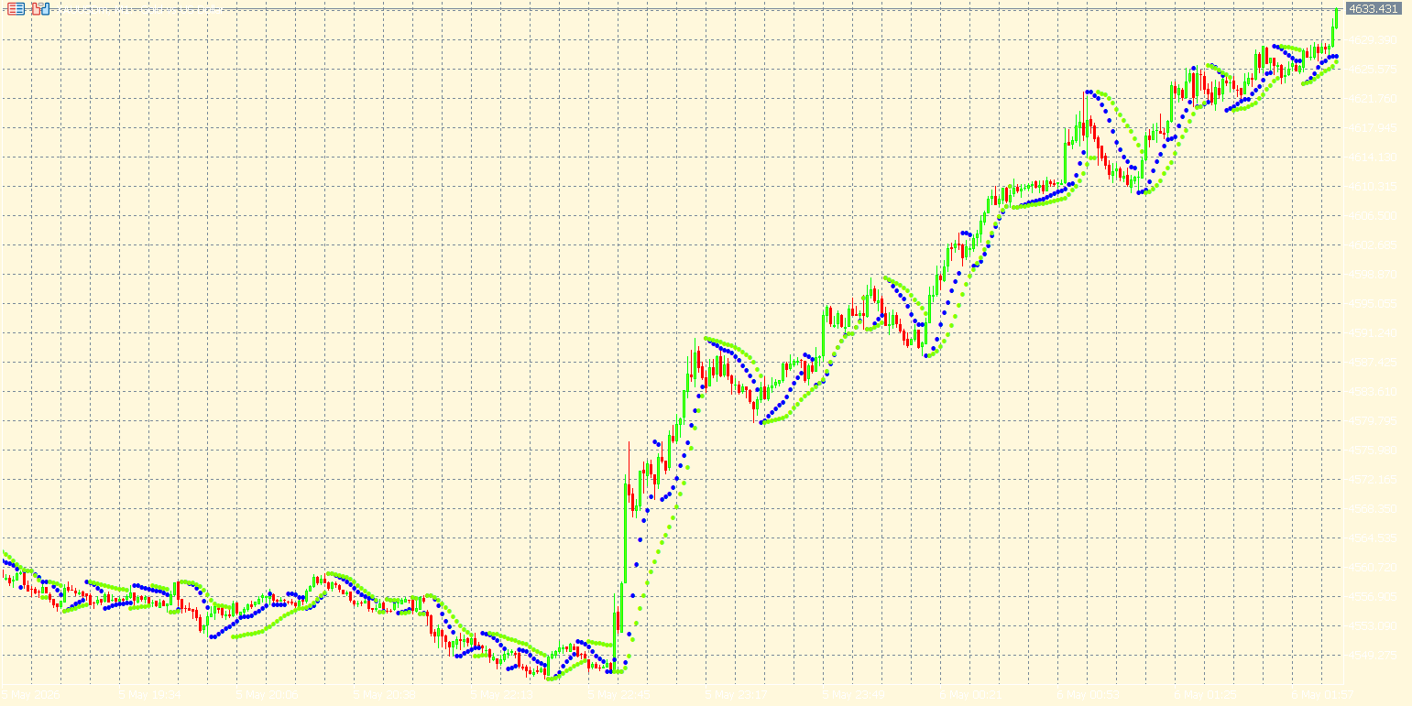

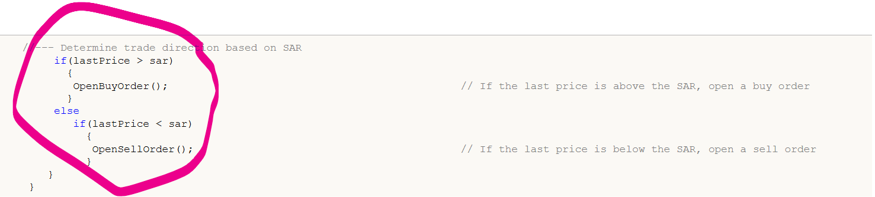
SAR_Step and SAR_Maximum: They control the sensitivity of the Parabolic SAR in price movement detection and Parabolic SAR indicator calculation.

- Đường SAR (0.05): Đây là đường "nhạy cảm" nhất. Vì Step lớn (0.05), hệ số gia tốc tăng rất nhanh, làm các chấm SAR bám cực sát vào giá. Nó giúp cậu bắt xu hướng sớm nhưng cũng dễ bị dính "nhiễu" (bị đảo chiều liên tục khi giá đi ngang).
Đường SAR (0.02): Đây là mức tiêu chuẩn (default). Nó cân bằng giữa độ nhạy và độ trễ, thường được dùng làm mốc so sánh chính.
-Đường SAR (0.01): Đây là đường "lì lợm" nhất. Với Step nhỏ, nó tăng tốc chậm và giữ khoảng cách xa với giá hơn. Đường này cực kỳ hữu ích để xác định xu hướng dài hạn và tránh các cú quét (stop hunt) ngắn hạn.

References
1. How to add Trailing Stop using Parabolic SAR
2. Automating Trading Strategies with Parabolic SAR Trend Strategy in MQL5: Crafting an Effective Expert Advisor - MQL5 Articles
3. Read more Interactive Position Labeling with CCanvas

ADX

ADX with RSI Confirmation

Zig Zag indicator

Reference
1. Zig Zag Indicator Trading Strategy — What Is It? (Backtest, Example, and Insights)
2. Price Action Analysis Toolkit Development (Part 19): ZigZag Analyzer

